Homework #3
# Due date: 16/Oct 23:59:59
# Put your answer in “Your Code)” section in each question
# For each solution you wrote, you MUST give comments for important lines. Without comments, your solutions will be considered copy&paste codes.
# You also need to provide a screenshot of your result (i.e., Logcat output).
# You must use Kotlin language.

- From an array of sentences, extract words by replacing punctuation with spaces, normalize them to lowercase, collect them into a set to remove duplicates, then print the sorted list of unique words and its count.

Code base)

val sentences = arrayOf(
"Seoul National University of Science and Technology!",
"Seoul station, and seoul TECH.",
"IT-Management; Kotlin & Android."
) // modify this array for teseting

// implement here

Log.d("HW03", "Original sentences:")
Log.d("HW03",sentences.toList().toString())
Log.d("HW03", "Unique words ($count): $sorted")

Output example)

Your Code)
class MainActivity : AppCompatActivity() {
override fun onCreate(savedInstanceState: Bundle?) {
super.onCreate(savedInstanceState)
setContentView(R.layout.activity_main)
val sentences = arrayOf(
"Seoul National University of Science and Technology!",
"Seoul station, and seoul TECH.",
"IT-Management; Kotlin & Android."
)
var index = 0
val words = mutableListOf<String>()
while (index < sentences.size) {
// normalization to lowercase
var sentence = sentences[index].lowercase()
// replace punctuations with space
for (c in sentence) {
if (!(c >= '0' && c <= '9') && !(c >= 'a' && c <= 'z')) {
sentence = sentence.replace(c, ' ')
}
}
// split sentences into words & save to list without duplication
for (word in sentence.split(' ')) {
if (word != "" && words.indexOf(word) == -1)
words.add(word)
}
index++
}
val count = words.size
// sort words in alphabetical order
val sorted = words.sorted()
Log.d("HW03", "Original sentences:")
Log.d("HW03", sentences.toList().toString())
Log.d("HW03", "Unique words ($count): $sorted")
}
}

Your Output)

2. Implement Grade class to make the following program work. The usage of Grade class is as follows:

Code base)

val math = 100 // modify these scores for test
val science = 90 // modify these scores for test
val english = 80 // modify these scores for test
val me = Grade(math, science, english)
Log.d("HW02","my math: $math, my science: $science, my english: $english")
Log.d("HW02","Average is ${me.average()}")

// implement Grade class

Output example)

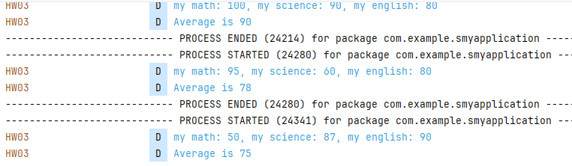

Your Code)
class MainActivity : AppCompatActivity() {
override fun onCreate(savedInstanceState: Bundle?) {
super.onCreate(savedInstanceState)
setContentView(R.layout.activity_main)
val math = 50 // modify these scores for test
val science = 87 // modify these scores for test
val english = 90 // modify these scores for test
val me = Grade(math, science, english)
Log.d("HW03","my math: $math, my science: $science, my english: $english")
Log.d("HW03","Average is ${me.average()}")
}
}
class Grade(math: Int, science: Int, english: Int) {
val scores = arrayOf(math, science, english)

// calculate average and convert data type from double to int
fun average(): Int {
return scores.average().toInt()
}

Your Output)
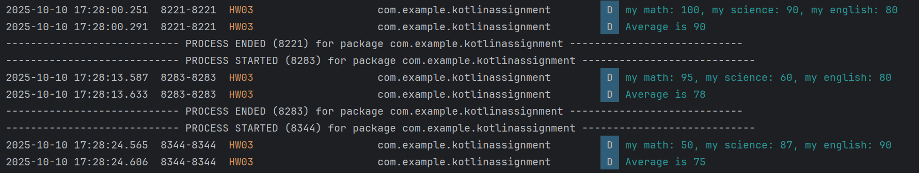

3. Create a data class for students with a name and score properties and expose an isPass() function that returns true when the score is at least 60.
a) Student class should be able to validate the range of the given score (i.e., 0<=score<=100); if violated, warning message should be printed, such as “Score must be 0..100 (got score for name)”.
b) isPass() function also need to consider the above condition

Code base)

// implement here (Student class)

// test code
val students = listOf(
Student("Jinwoo", 92), // you can modify here for testing
Student("Sora", 58),
Student("Min", 60)
)

for (st in students) {
Log.d("HW02", "${st.name}: ${if (st.isPass()) "Pass" else "Fail"} (score=${st.score})")
}

Output example)

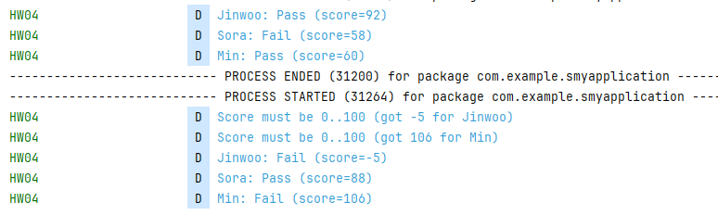

Your Code)
class MainActivity : AppCompatActivity() {
override fun onCreate(savedInstanceState: Bundle?) {
super.onCreate(savedInstanceState)
setContentView(R.layout.activity_main)
// implement here (Student class)
data class Student(val name: String, val score: Int) {
init {
// check validity at class initializing
if (!validScore())
Log.d("HW03", "Score must be 0..100 (got ${score} for ${name})")
}
fun validScore(): Boolean {
return (score >= 0 && score <= 100)
}
fun isPass(): Boolean {
if (validScore())
return (score >= 60)
return false
}
}
// test code
val students = listOf(
Student("Jinwoo", -5), // you can modify here for testing
Student("Sora", 88),
Student("Min", 106)
)
for (st in students) {
Log.d("HW03", "${st.name}: ${if (st.isPass()) "Pass" else "Fail"} (score=${st.score})")
}
}
}

Your Output)
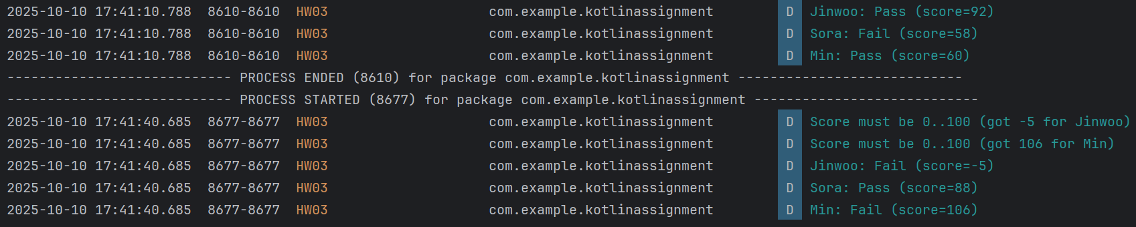
4. Implement a BankAccount class that 1) keeps balance data, 2) accepts only positive deposits and withdrawals by checking inputs, 3) prevents overdrafts by printing a warning message instead of changing the balance, and 4) logs the balance after every operation.

- Assume that initial balance is always equal to or greater than 0.
- You should implement property initializer, deposit/withdraw functions.

Code base)

// usage
val acc = BankAccount(100)
acc.deposit(50)
acc.withdraw(30)
acc.withdraw(200)
acc.deposit(-30)
acc.withdraw(-30)
acc.deposit(80)
acc.withdraw(200)

// implement class BankAccount

Output)

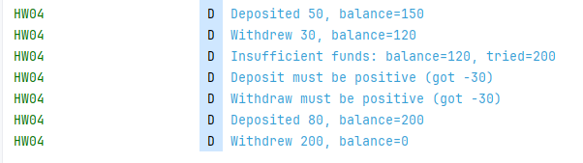

Your Code)
class MainActivity : AppCompatActivity() {
override fun onCreate(savedInstanceState: Bundle?) {
super.onCreate(savedInstanceState)
setContentView(R.layout.activity_main)
// usage
val acc = BankAccount(100)
acc.deposit(50)
acc.withdraw(30)
acc.withdraw(200)
acc.deposit(-30)
acc.withdraw(-30)
acc.deposit(80)
acc.withdraw(200)
}
// implement class BankAccount
data class BankAccount(var balance: Int) {
fun deposit(money: Int) {
// deposit money
if (money > 0) {
balance += money
Log.d("HW03 ", "Deposited ${money}, balance=${balance}")
}
// non-positive money detected
else {
Log.d("HW03", "Deposit must be positive (got ${money})")
}
}
fun withdraw(money: Int) {
// withdraw money
if (money > 0) {
// withdraw success
if (balance >= money) {
balance -= money
Log.d("HW03 ", "Withdraw ${money}, balance=${balance}")
}
// withdraw failure
else
Log.d("HW03", "Insufficient funds: balance=${balance}, tried=${money}")
}
// non-positive money detected
else {
Log.d("HW03", "Withdraw must be positive (got ${money})")
}
}
}
}

Your Output)
